The Seven Principles of American Government
Wayne Davidson M. Ed.
Da Vinci School for Science and the Arts
The Constitution is built upon seven basic principles of government.
The Framers of the Constitution used these principles to create the “supreme law” of our land.
Who were the framers?
- James Madison
- Thomas Jefferson- author of the Declaration of Independence, who had to leave for France during the Constitutional Convention.
- George Washington- President of the Convention, who stepped in in Jefferson’s absence.
- Benjamin Franklin.
Constitutional Convention met in Philadelphia in May-June 1787, to replace the woefully inadequate Articles of Confederation, which was a very weak document.
PRINCIPLES
1. Popular Sovereignty- This principle states that the source of governmental power lies with the people.
- PEOPLE RULE
- The Preamble to the Constitution begins with this bold phrase,
“We the People...” These words announce that in the United States, the people establish government and give it its power. The people are sovereign. Since the government receives its power from the people, it can govern only with their consent.
- The people’s power comes in a form of democracy. We have the right to push into a touch screen
our choices for our government!
2. Limited Government- Because the people are the source of government power, the government has only as much authority as the people give it. A limited government is a system in which the primary leaders have very little governing powers over the decisions and laws that are created without approval from other branches or leaders within the government.
- Much of the Constitution, in fact, consists of specific limitation on government power. (Bill of Rights)
- Limited government means that neither the government or any government official is “above the law” and can overstep these constitutional bounds.
3. Separation of Powers- Government power is not only limited: it is also divided. The doctrine that the individual branches of government (executive, legislative, judicial) have separate and unique powers the others cannot infringe upon.
- Legislative Branch- (Congress)
- Executive Branch-(President)
- Judicial Branch- (Supreme Court)

- Checks and Balances-The system of checks and balances is an important part of the Constitution, where each of the three branches of government can limit the powers of the others. This way, no one branch becomes too powerful. Each branch “checks” the power of the other branches to make sure that the power is balanced between them.

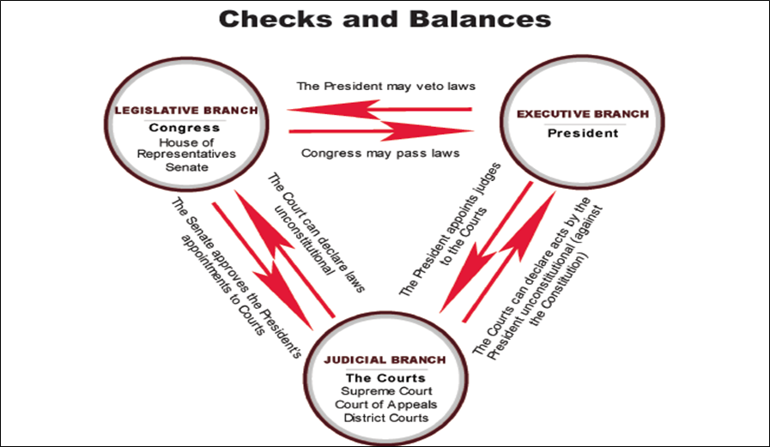
- Judicial Review- A process under which executive and legislative actions are subject to review by the judiciary. A court with judicial review power may invalidate laws and decisions that are incompatible with a higher authority; an executive decision may be invalidated for being unlawful or repugnant to a statute, and a statute may be invalidated for violating the terms of a written constitution.
- Who decides whether an act of government oversteps the limits placed on it by the Constitution?
- Historically, the judges in the federal courts have made the decisions. The principle of judicial review was established early in the history of the nation.
- Before Marbury v. Madison (1803), all big profile cases were to be heard in Congressional Federal Courts. (Judiciary Act of 1789)
- Marbury v. Madison (1803)
- In 1800 Thomas Jefferson wins the presidency. He defeats John Adams.
- Before Jefferson actually begins his term, (March 4, 1801), William Marbury wants the position of Justice of the Peace in Washington D.C.
- He was approved by the Senate, and (soon-to-be-leaving office), John Adams signs the appointment to JP.
- Jefferson tells Secretary of State James Madison, “No way, new sheriff in town. Hiring window is closed.”
- Marbury sues Madison for not delivering his appointment to office.
- Chief Justice John Marshall declares the Supreme Court’s power to review government acts, including cases with government officials, states, treaties.
- Judicial Review is born. It means that federal courts have the power to review government acts and to nullify, or cancel, any that are unconstitutional, or violate the provision of the Constitution.

- Federalism- A principle of government that defines the relationship between the central government at the national level and its constituent units at the regional, state, or local levels. Under this principle of government, power and authority is allocated between the national and local governmental units, such that each unit is delegated a sphere of power and authority only it can exercise, while other powers must be shared.
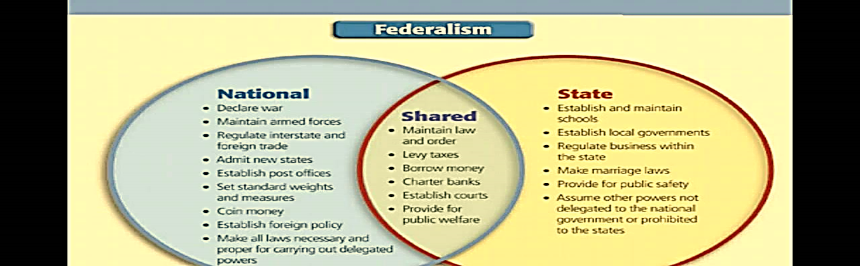
- A federal system divides power between a central government and smaller, local governments.
- This sharing of power is intended to ensure that the central government is powerful enough to be effective, yet not so powerful as to threaten States or citizens.
- It also allows individual States to deal with local problems at the local level—so long as their actions are constitutional.

- Republicanism- An ideology of being a citizen in a state as a republic under which the people hold popular sovereignty.
- In outlining our government “of the people and by the people”, the Constitution connects the citizenry of the United States to our government positions by way of elections.
- This election process confirms the principle of popular sovereignty by allowing the people of America to choose their leaders.

